**Lab 4 Instructions:**

Pertaining to setting up your Teradata University Network login and gaining practical experience using the MicroStrategy BI tool.  
  
Feel free to explore the site to get more familiar with MicroStrategy. I recommend printing the Hands-on Assignment 4 before completing the tutorial (attached).  
  
1. Create a new student account - Go to http://www.teradatauniversitynetwork.com/tun/ and click on Student Registration in the upper right.  
  
2. The student access password is "Analytics" (no quotes).  
  
3. Complete the registration form. Now you have access to the site and MicroStrategy.  
  
4. At the bottom of the home page, click on Software -> Microstrategy under the yellow header of 'Apply & Do'.  
  
5. Explore the site to learn more about MicroStrategy. This background information will help you understand the hands-on assignment.  
  
6. Click on the ‘MicroStrategy 9 Analysis Modules’ link (It's on the landing page after clicking the MicroStrategy 9 link on step 4).  
  
7. Click on the 'Sales Force Analysis Module' link.  
  
8. You are now on step 3 of the MicroStrategy Demo (Assignment 4). Complete the demo/tutorial.

Pipeline Analysis

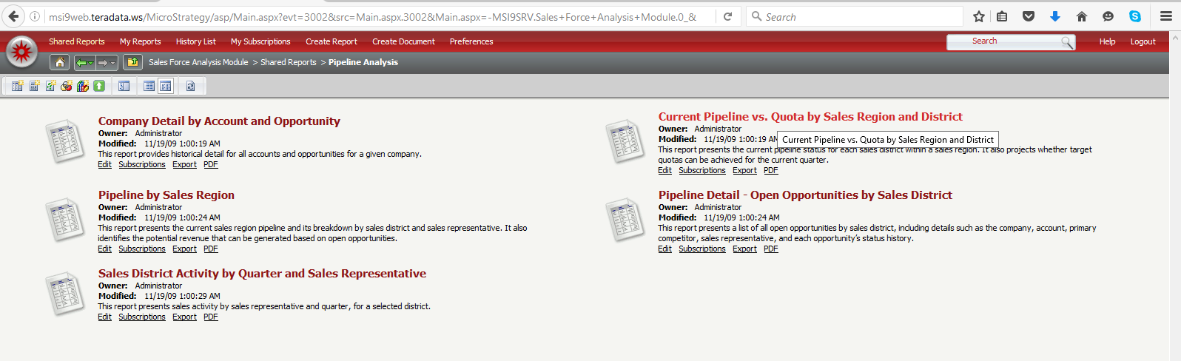

Current Pipeline vs Quota by Sales Region and District

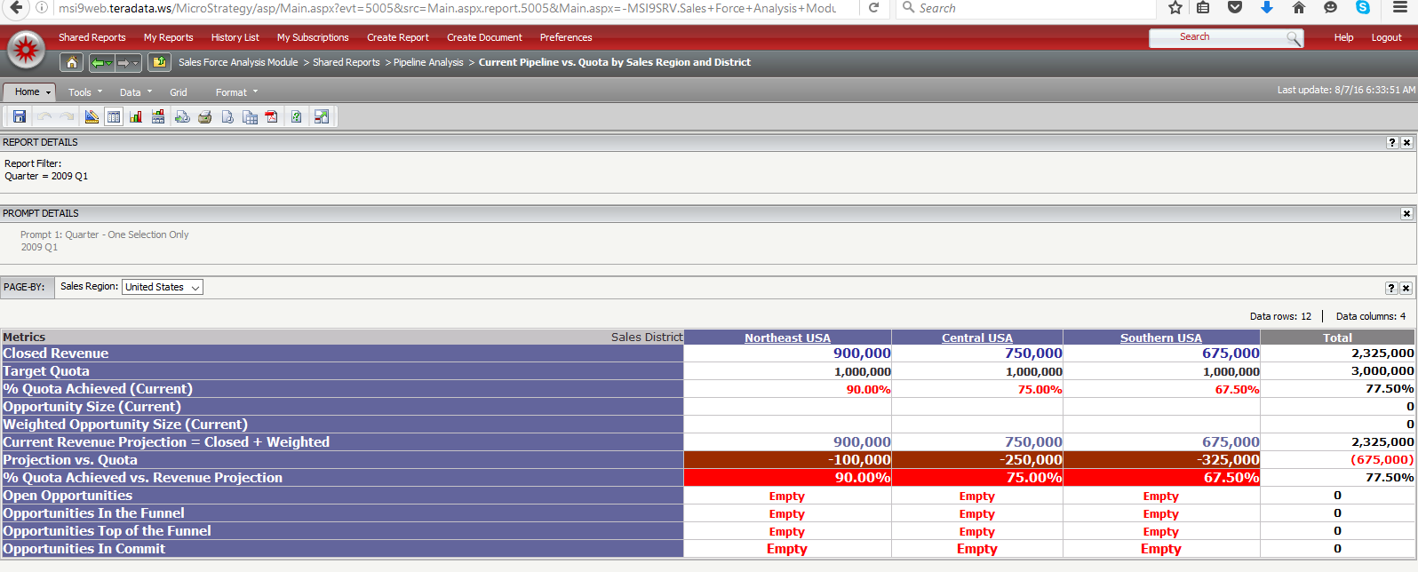

Southern Europe Drill Down

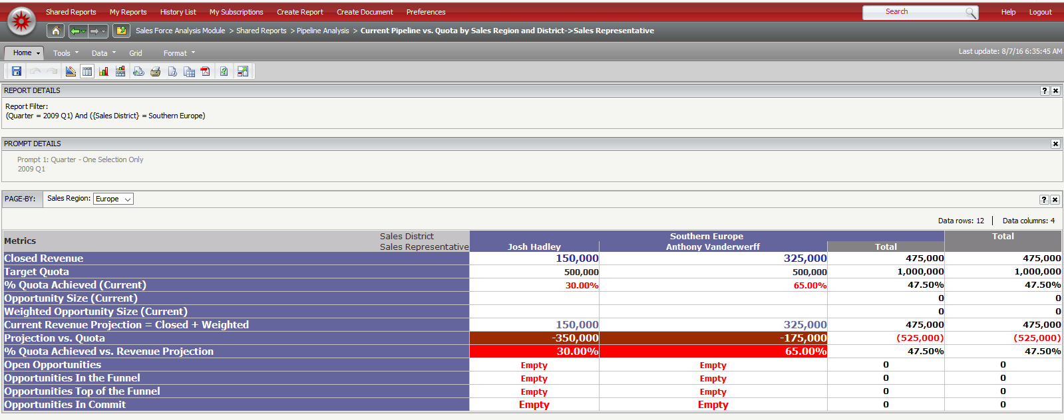

Pipeline Open opportunities by Sales Distict- Europe

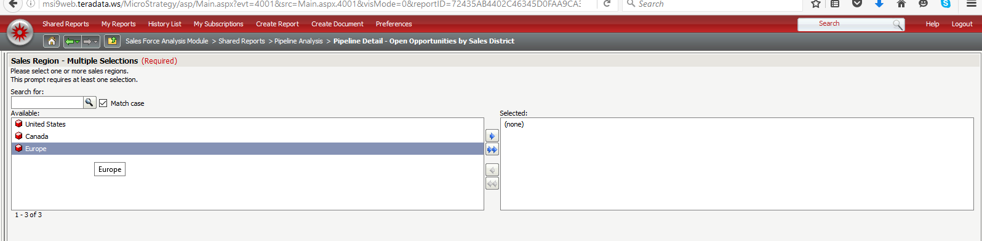  
Northern Europe Opportunities

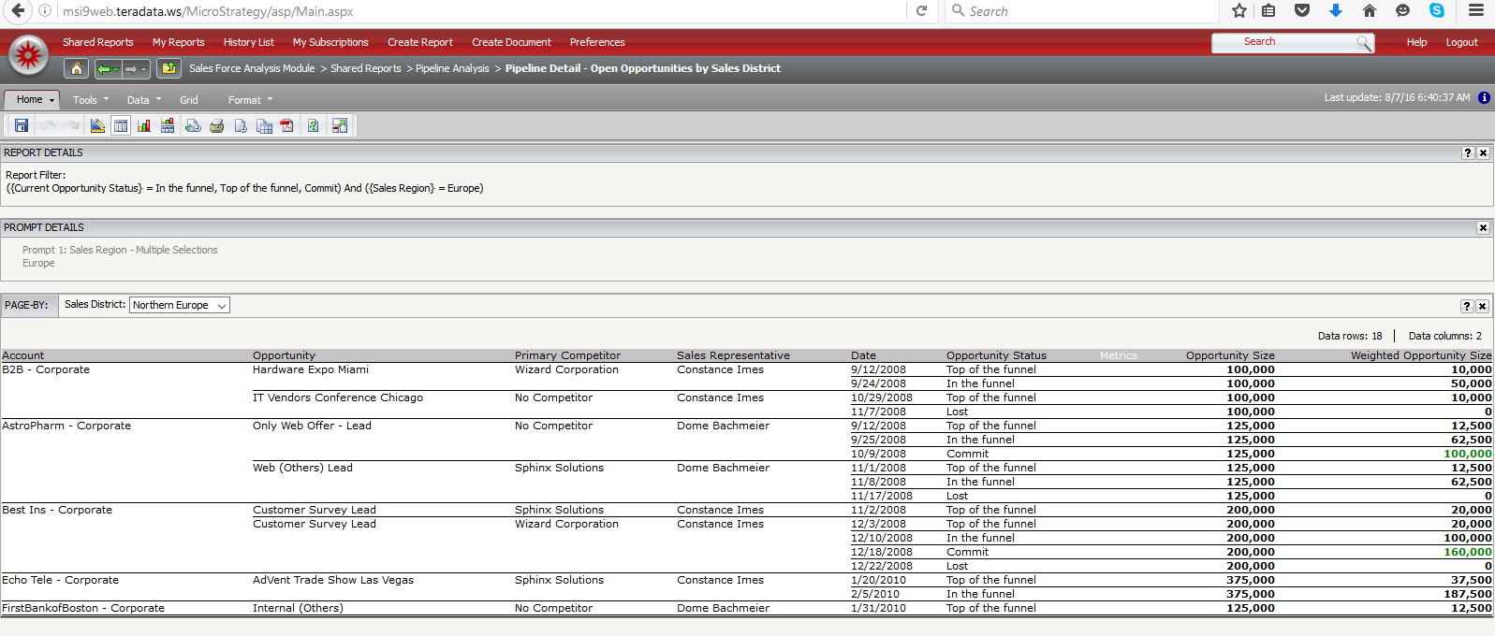

Southern Europe Opportunities

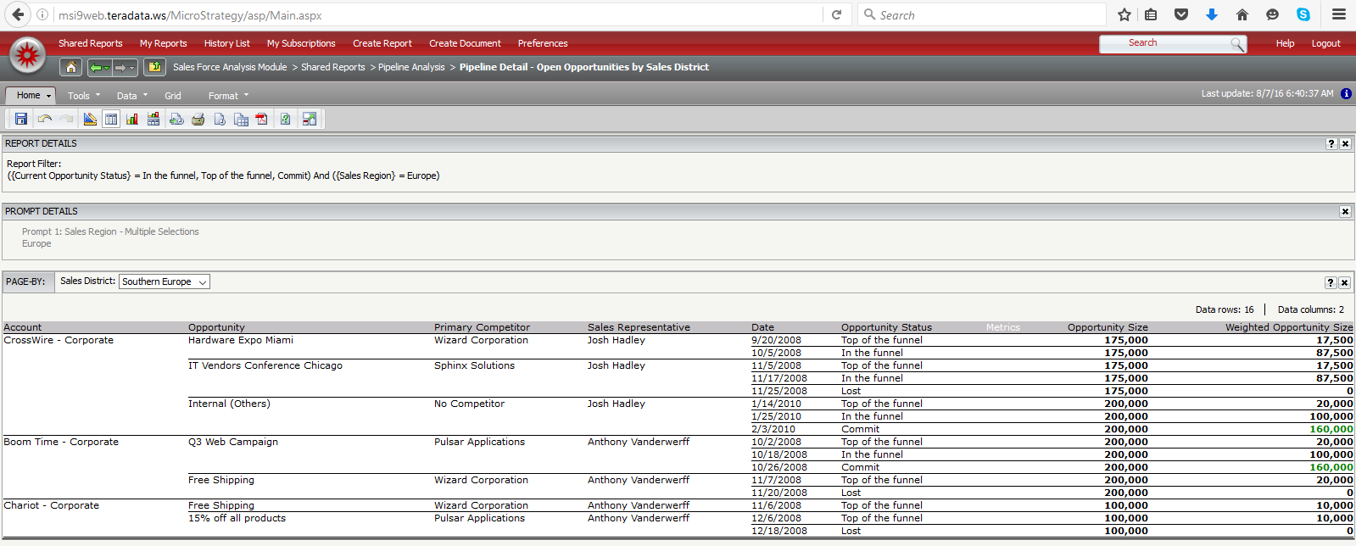

Selecting Southern Europe in Report Filter

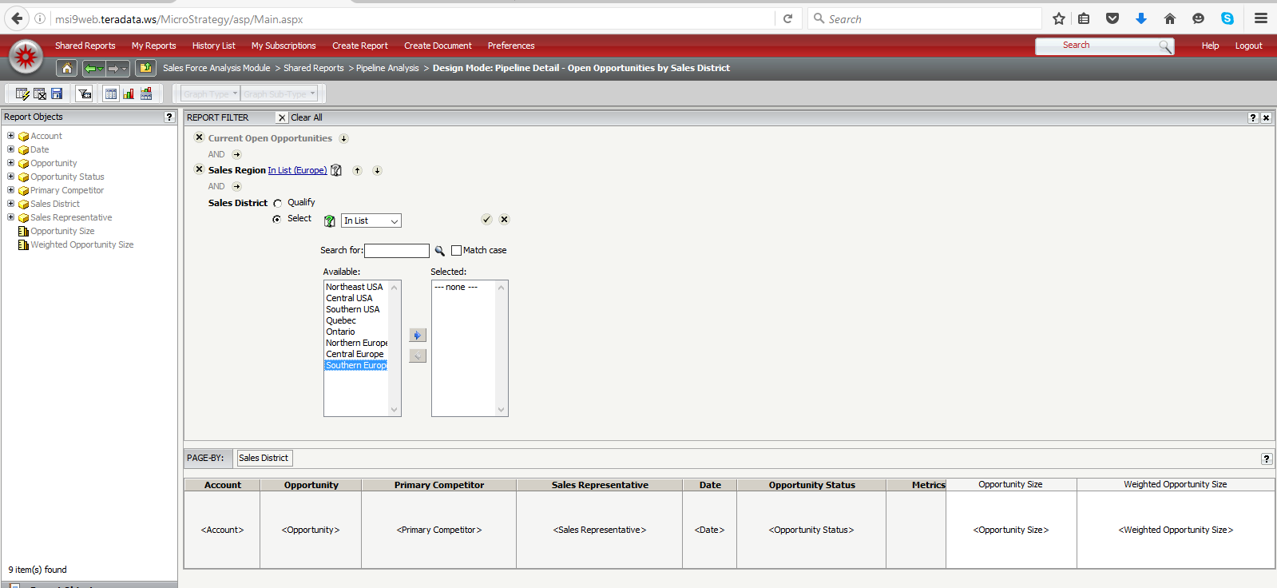

Run report with Europe Region, Southern Europe Filter

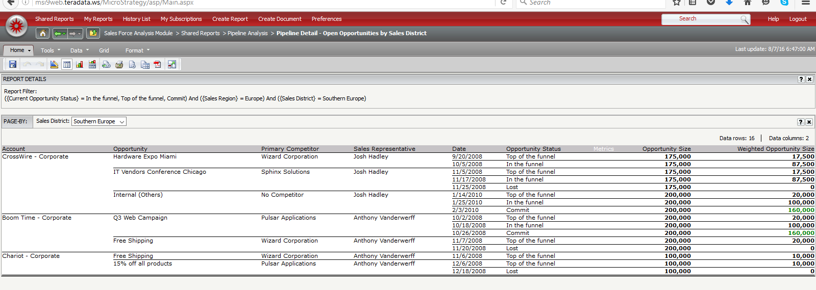

Remove Page By Option

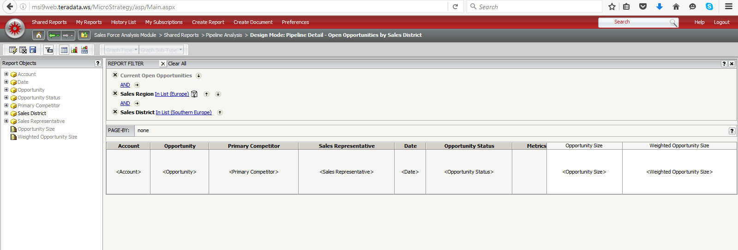

Save report template for later use

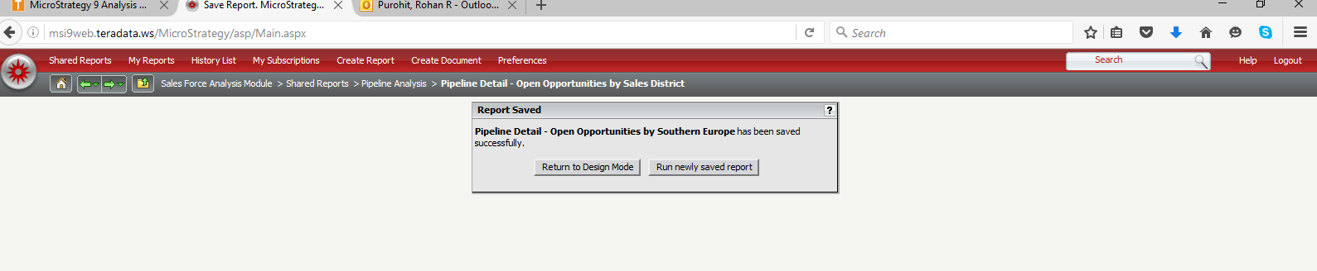

Run New Report

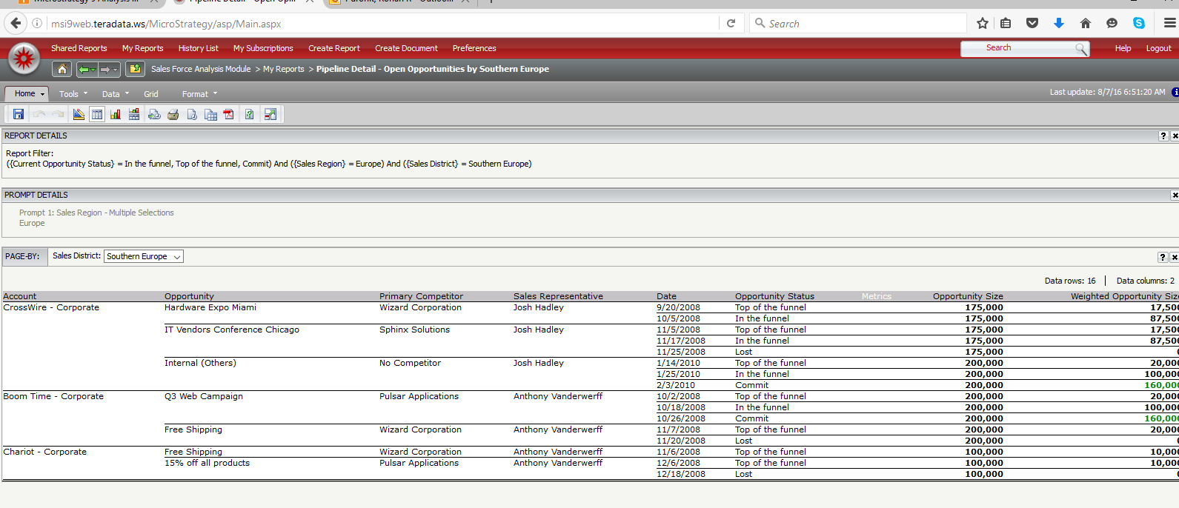

Company Detail by Account and Opportunity

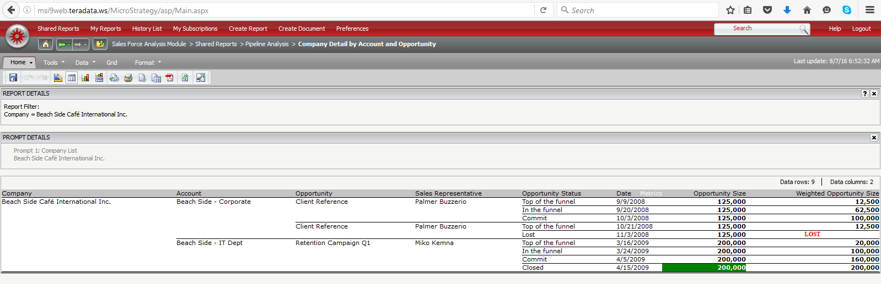

Sales District by Quarter and Sales Representative.

